## Silong Esteban Abada

1. 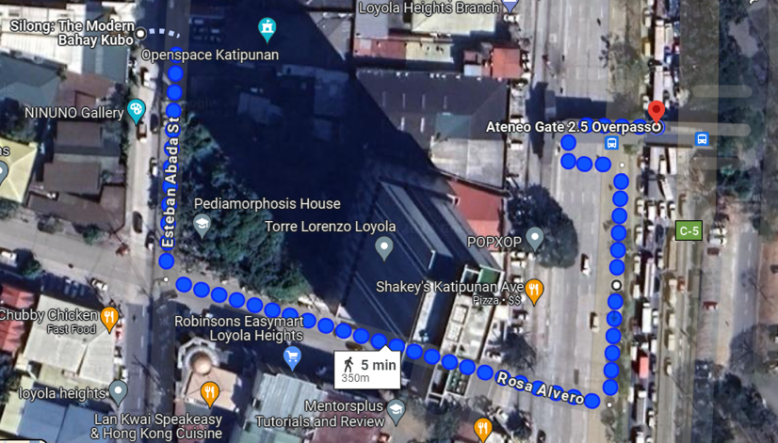Address: 47 Esteban Abada St., Loyola Heights, Quezon City, Manila, Philippines, 1810
2. Phone Number: +63 917 621 2607
3. Email: [info@47east.ph](mailto:info@47east.ph)
4. Website: <https://47east.ph/contact/>
5. Modes to get to Ateneo:
6. Walking (5-7 minutes to Ateneo Gate 2.5)
   * From Silong, walk to Rosa Alvero intersection near 7/11 and Robinsons Easymart. Turn left to the direction of Robinsons Easymart and McDonalds
   * Walk straight until you reach C5 (Katipunan Avenue), then turn left until you see a footbridge. This is the footbridge directing to Ateneo Gate 2.5.
7. Price Range:
   * Php 2800 for a room for 2 to Php 5,500 for a room for 4 (Family Room)
8. Where to reserve: Through their [website](https://47east.ph/silong/) or through [Agoda](https://www.agoda.com/silong-the-modern-bahay-kubo/hotel/manila-ph.html?finalPriceView=1&isShowMobileAppPrice=false&cid=1918349&numberOfBedrooms=&familyMode=false&adults=2&children=0&rooms=1&maxRooms=0&checkIn=2024-08-4&isCalendarCallout=false&childAges=&numberOfGuest=0&missingChildAges=false&travellerType=1&showReviewSubmissionEntry=false&currencyCode=PHP&isFreeOccSearch=false&pushId=CgYIgIm7tQYSBgiArMC1BhgBIPyrrQ8qDBgBKggiAggBKgIIAw%3D%3D3d035fb2-e923-3110-b8bd-8391580baa52_20240602_06&los=1&searchrequestid=7631dce6-511d-4245-bbdd-e92c2a4832b7&ds=QJsvZxrEgCtd7Qj5).

## Studio 89

1. 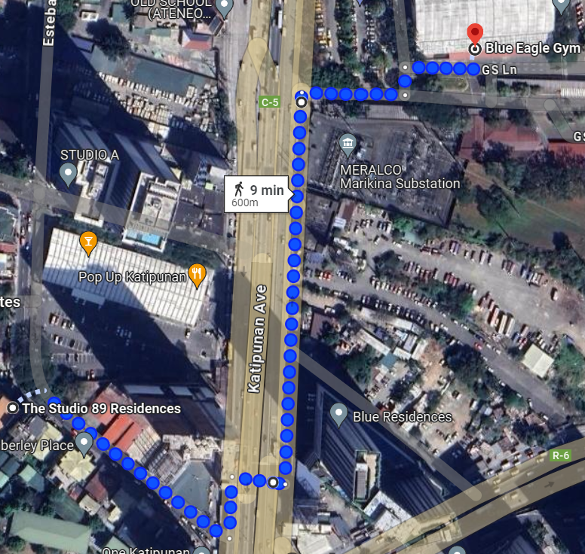Address: 17 Esteban Abada Street, Loyola Heights, Quezon City, 1108 Manila, Philippines
2. Phone Number: +63 945 801 1688
3. Email: [studio89residences@gmail.com](mailto:studio89residences@gmail.com)
4. Website: <https://www.facebook.com/thestudio89/>[1]
5. Modes to get to Ateneo:
   1. Walking (15 minutes to Ateneo Gate 1)
      * From Studio 89, walk towards Katipunan Avenue near 7/11.
      * Cross the road towards the northbound direction along SMDC Blue Residences.
      * Walk straight towards Gate 1.
   2. Riding a Tricycle (5 minutes to inside Ateneo, Php 40)
      * From Studio 89, there is a nearby tricycle terminal. Ask the drivers for tricycles that have Ateneo stickers.
      * Ask the driver to drop you off at JSEC.
6. Price Range: Php 1,900 for 2 twin beds to Php 3,700 for 4 twin beds.
7. Where to reserve
   1. [Agoda](https://www.agoda.com/the-studio-89-residences/hotel/manila-ph.html?locale=en-us&ckuid=c3c67107-4f94-4e58-866e-065c660c0634&prid=0&currency=PHP&correlationId=1ebe40bf-b6a1-481c-8622-27a859114c8e&analyticsSessionId=-8952019886091163848&pageTypeId=7&realLanguageId=1&languageId=1&origin=PH&stateCode=NUE&cid=1844104&userId=c3c67107-4f94-4e58-866e-065c660c0634&whitelabelid=1&loginLvl=0&storefrontId=3&currencyId=18&currencyCode=PHP&htmlLanguage=en-us&cultureInfoName=en-us&machineName=hk-pc-2f-acm-web-user-66cdf65886-8q949&trafficGroupId=1&sessionId=gjr4bndhbddd3r11l5xdq1tf&trafficSubGroupId=84&aid=130589&useFullPageLogin=true&cttp=4&isRealUser=true&mode=production&browserFamily=Chrome&cdnDomain=agoda.net&checkIn=2024-08-01&checkOut=2024-08-02&rooms=1&adults=2&childs=0&priceCur=PHP&los=1&textToSearch=STUDIO+89+KATIPUNAN+QC&productType=-1&travellerType=1&familyMode=off&ds=Ab4Wt5iECZsJsH82)
   2. [Booking](https://www.booking.com/hotel/ph/the-studio-89-residences.html)

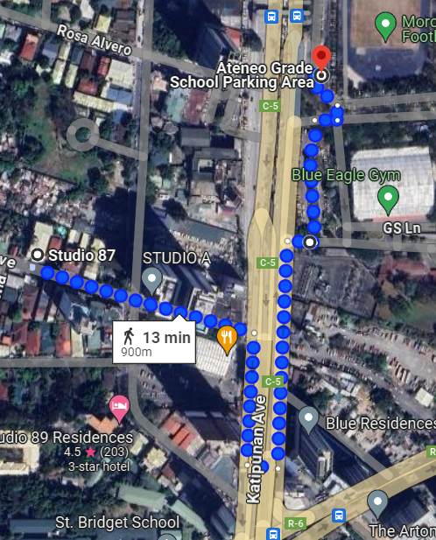

## Studio 87

1. Address: 87 Xavierville Ave Loyola Heights, Quezon City, Philippines
2. Phone Number: +63 2 8927 9098
3. Email: [thestudio87@yahoo.com](mailto:thestudio87@yahoo.com)
4. Website: <https://www.facebook.com/thestudio87/>
5. Modes to get to Ateneo:
   1. Walking (13 minutes to Ateneo Gate 1)
      1. From Studio 87 along Xavierville Ave.
      2. Cross the road towards the northbound direction along SMDC Blue Residences.
      3. Walk straight towards Gate 1.
   2. Riding a Tricycle with Ateneo Sticker (5 minutes to inside Ateneo, Php 40)
      1. From Studio 87, there is a nearby tricycle terminal. Ask the drivers for tricycles that have Ateneo stickers.
      2. Ask the driver to drop you off at JSEC.
   3. Riding a Tricycle without Ateneo Striker (3 minute ride + 2 minute walk, Php 40)
      1. If there are no tricycle drivers with the Ateneo sticker, you may ask any tricycle driver to drop you off at Shakey’s near Gate 2.5. Then, take the footbridge
6. Price Range: Php 1,500 – Php 2,000 for a twin bed. There are no 4-person accommodation for this location.
7. Where to reserve:
   1. [Agoda](https://www.agoda.com/the-studio-87-residences/hotel/manila-ph.html?locale=en-us&ckuid=c3c67107-4f94-4e58-866e-065c660c0634&prid=0&currency=PHP&correlationId=5daab40a-15e8-4d63-a9bb-d01c5eb77b54&analyticsSessionId=-8952019886091163848&pageTypeId=7&realLanguageId=1&languageId=1&origin=PH&stateCode=NUE&cid=1844104&userId=c3c67107-4f94-4e58-866e-065c660c0634&whitelabelid=1&loginLvl=0&storefrontId=3&currencyId=18&currencyCode=PHP&htmlLanguage=en-us&cultureInfoName=en-us&machineName=hk-pc-2f-acm-web-user-66cdf65886-5h26s&trafficGroupId=1&sessionId=gjr4bndhbddd3r11l5xdq1tf&trafficSubGroupId=84&aid=130589&useFullPageLogin=true&cttp=4&isRealUser=true&mode=production&browserFamily=Chrome&cdnDomain=agoda.net&checkIn=2024-08-01&checkOut=2024-08-02&rooms=1&adults=2&childs=0&priceCur=PHP&los=1&textToSearch=The+Studio+87+Residences&productType=-1&travellerType=1&familyMode=off&ds=x8OL5rA0fwuqxsPa)
   2. [Booking](https://www.booking.com/hotel/ph/the-studio-87-residences.html)

Soto Grande Hotel

1. Address: 181 Katipunan Avenue, Project 4, Quezon City, 1109 Metro Manila, Philippines
2. Phone Number: +63 917 125 8847
3. Email: reservations.katipunan@

sotograndehotels.com

1. Website: <https://www.sotograndehotels.com/our-hotels/sotogrande-katipunan/>
2. Modes to get to Ateneo:
   1. Grab: Book a grab from Soto Grande Hotel and pin you destination to Ateneo.
3. Price Range: Php 3,600 – Php 7,000
4. Where to reserve:
   1. [Direct Website](https://book-directonline.com/properties/sotograndekatipunandirect)

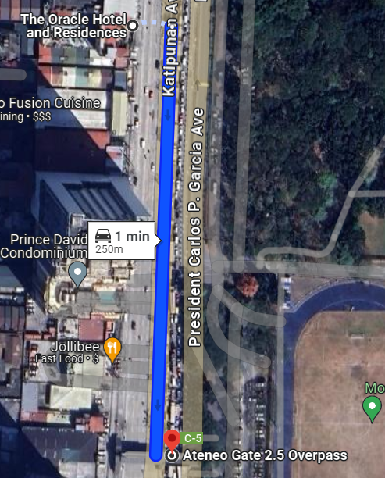

## Oracle Hotel and Residences

1. Address: 317 Katipunan Avenue, Loyola Heights, Quezon City, Philippines
2. Phone Number: +63 2 8926 7777 (telephone), +63 917 719 5852 (mobile)
3. Email: [sales@oraclehotel.com.ph](mailto:sales@oraclehotel.com.ph)
4. Website: <https://www.oraclehotel.com.ph/en/>
5. Modes to get to Ateneo:
   1. Walking (3 minutes to Gate 2.5). Walk straight ahead to the footbridge. This will directly lead you to Ateneo Gate 2.5
6. Price Range: Php 2,300 – Php 4,000
7. Where to reserve:
   1. [Direct Website](https://www.oraclehotel.com.ph/en/reservation)
   2. [Agoda](https://www.agoda.com/the-oracle-hotel-residences/hotel/manila-ph.html?finalPriceView=1&isShowMobileAppPrice=false&cid=1844104&numberOfBedrooms=&familyMode=false&adults=2&children=0&rooms=1&maxRooms=0&checkIn=2024-08-1&isCalendarCallout=false&childAges=&numberOfGuest=0&missingChildAges=false&travellerType=1&showReviewSubmissionEntry=false&currencyCode=PHP&isFreeOccSearch=false&tspTypes=8&los=1&searchrequestid=4581b79e-9598-4e07-aa09-79ab683a7e6f&ds=Q9QapYhGcYOPFSxz)

## Oyo 809 Crowne One

1. A map of a city

   Description automatically generatedAddress: SariSari, Esteban Abada, Ronas Garden Neighbourood Association, Hardin ng Rosas, 3rd District, Quezon City, Eastern Manila District, Metro Manila, 1108, Philippines, Quezon City
2. Phone Number: +63 2 8540 0051
3. Email: N/A
4. Website: <https://www.oyorooms.com/ph/113835/>
5. Modes to get to Ateneo:
   1. Walking (3 minutes to Gate 3.5). Walk straight until you reach F. Dela Rosa St. Turn right, then after reaching Katipunan Avenue, turn left to Regis Center. Use the footbridge to cross to Ateneo Gate 3.5
6. Price Range: Php 900 – Php 2,300
7. Where to reserve:
   1. [Direct Website](https://www.oyorooms.com/ph/113835/)
   2. [Booking](https://www.booking.com/hotel/ph/oyo-809-crowne-one-condo.html)

## Some Notes

1. None of the accommodations had prices for January 2025. All of them were restricted to until December 2024 only.
2. We stayed at Studio 89 last year, and it was a pleasant experience. It was convenient because the tricycle station is just beside the Studio, so the participants of the conference would not have to go further for transportation.
3. Another good pick is Oracle Hotel since it’s just in front of Ateneo Gate 2.5.

1. At the time of writing, their website is broken, and only their Facebook page is active.